8.8: a) The magnitude of the velocity has changed by

and so the magnitude of the change of momentum isto three figures. This is also the magnitude of the impulse. b) From Eq. (8.8), the magnitude of the average applied force is 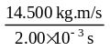=7.25